Fig 1.
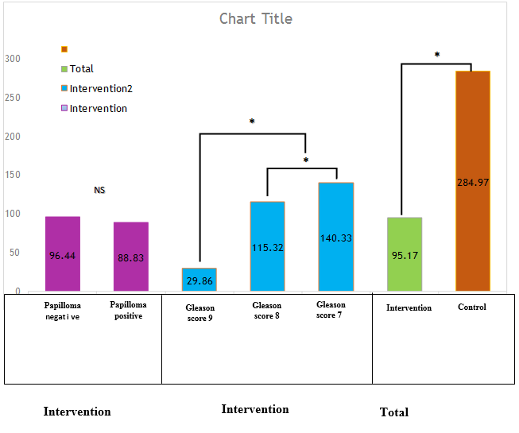

Comparison of interleukin 12 levels (Con -pg / ml) in experimental and control groups, based on condition (positive or negative Papillomavirus) and Gleason score. There was no significant difference between the levels of interleukin-12 in different age groups (P> 0.05). The difference between the levels of IL-12 in Gleason score 7,8 and 9 was significant (P <0.05) and The difference between the levels of IL-12 in the experimental and control was significant too (p<0.05). NS: no significant.*: significant symbol

