**MDC/CCL22 DEPLETION IN COVID-19 AND POST-COVID**

**СНИЖЕНИЕ MDC/CCL22 ПРИ COVID-19 И В ПОСТКОВИДНОМ СИНДРОМЕ**

Коробова З. Р.1,2

Тотолян А. А. 1,2

1Санкт-Петербургский научно-исследовательский институт эпидемиологии и микробиологии им. Пастера

2 Первый Санкт-Петербургский государственный медицинский университет им. И.П. Павлова

**MDC/CCL22 DEPLETION IN COVID-19 AND POST-COVID**

Korobova Z. R.a,b

Totolian A. A. a,b

a Saint Petersburg Pasteur Institute

b Pavlov First State Medical University of Saint Petersburg

**Резюме.**

В этой статье мы исследуем роль макрофагального хемокина MDC/CCL22 в иммунитете против COVID-19.

Материалом для исследования послужили образцы плазмы от 289 пациентов с подтвержденным COVID-19, получавших лечение в специализированных инфекционных стационарах, развернутых во время пандемии. Образцы крови отбирались при поступлении, на 7-10 сутки от начала инфекции. Для этих же пациентов проводилось генотипирование варианта вируса в носоглоточных мазках. Так же в исследование вошли образцы крови 69 реконвалесцентов пациентов, перенесших COVID-19 более чем за месяц до начала исследования. Кроме того, в качестве контроля в исследование вошел 51 здоровый донор. Концентрацию MDC/CCL22 и других цитокинов и хемокинов измеряли с помощью мультиплексного анализа с использованием технологии Luminex MagPix.

Результаты показали, что у пациентов с COVID-19 уровень макрофагального хемокина MDC/CCL22 в плазме был значительно ниже, независимо от штамма SARS-CoV-2, по сравнению со здоровыми донорами. Кроме того, у реконвалесцентов так же до сих пор отмечались сниженные уровни MDC/CCL22, что указывает на то, что истощение этого хемокина может сохраняться даже после выздоровления.

В рамках нашей работы мы предлагаем два механизма, которые могут объяснить причины, приводящие к снижению MDC/CCL22. Во-первых, связывание и инактивация этого хемокина пептидами SARS-CoV-2 может снижать его фунциональну активность. Другим предполагаемым механизмом снижения этого хемокина является «выключение» его эффекторных клеток (например, дендритных клеток и макрофагов) из иммунного процесса.

Лимфопению после COVID-19 потенциально можно объяснить отсутствием MDC/CCL22. Это может привести к сдвигу воспалительной реакции в сторону гиперактивации, что потенциально может объяснить тяжесть течения COVID-19 относительно других респираторных инфекций, особенно на начальных этапах пандемии.

Наше исследование подчеркивает важность макрофагального хемокина MDC/CCL22 в иммунитете к COVID-19. Понимание механизмов концентраций этого хемокина может дать новое представление о патогенезе COVID-19.

**Ключевые слова:** macrophage derived chemokine, COVID-19, chemokines, multiplex analysis, post-COVID, dendritic cells

**Abstract.**

In this article, we explore the role of macrophage-derived chemokine (MDC/CCL22) in COVID-19 immunity. The study included plasma samples of 289 patients with PCR-verified COVID-19 from specialized hospitals. The blood samples were collected at admission, approximately 7 days after the start of infection. Genetic testing of the virus was performed in nasopharyngeal swabs to determine the viral strain for each patient. We also included blood plasma of 69 convalescent patients who had recovered from COVID-19 more than a month prior to the study. Additionaly, 51 healthy donors were included in the study as controls.

The concentration of MDC/CCL22 and other cytokines and chemokines were measured with multiplex analysis, using Luminex MagPix Technology. The results showed that COVID-19 patients had significantly lower MDC levels in their plasma, regardless of the SARS-CoV-2 strain, compared to healthy donors. This finding suggests that MDC/CCL22 depletion may play a role in COVID-19 immunity. Furthermore, convalescent patients still showed decreased concentrations of MDC/CCL22 more than a month after infection, indicating that this depletion may persist even after recovery.

We propose two mechanisms that can explain the reasons leading to MDC/CCL22 depletion. The first is binding and inactivation of this chemokine with SARS-CoV-2 peptides, making it not only undetectable for commerical kits, but also less functionally active. Another mechanism is the dysfunction of its effector cells (e.g., DCs and macrophages).

Lymphopenia following COVID-19 can potentially be explained by the absence of MDC/CCL22. This may lead to a shift towards hyperactivation in the inflammatory response, potentially explaining the severity of COVID-19.

This research sheds light on the importance of MDC/CCL22 in COVID-19 immunity and highlights the need for further investigation into its role in the disease. Understanding the mechanisms behind MDC/CCL22 depletion could provide new insights into the pathogenesis of COVID-19 and inform the development of potential treatments.

**Ключевые слова:** макрофагальный хемокин, COVID-19, хемокины, мультиплексный анализ, пост-ковидный синдром, дендритные клетки

**Introduction.**

COVID-19 is an acute infectious disease caused by the RNA-based SARS-CoV-2 virion of the genus Betacoronavirus. The COVID-19 pandemic has affected millions of people worldwide, causing significant morbidity and mortality [8].

COVID-19 enters cells through the ACE 2 receptor, which is found in various human cells [10]. The virus primarily targets cells in the respiratory system, causing inflammation and inhibiting the ACE 2 receptor, leading to increased angiotensin II secretion and subsequent activation of inflammatory transcription factors [4]. These conditions can potentially trigger a cytokine storm, resulting in enhanced inflammation [3].

Understanding the immune response to SARS-CoV-2, the virus that causes COVID-19, is crucial in developing effective vaccines and therapeutics. In this article, we review the current knowledge on COVID-19 immunity from chemokine standpoint. Specifically, we address our findings in terms of macrophage-derived chemokine in blood plasma and its changes in acute COVID-19 and convalescent patients.

Materials and methods:

Study population: The study included 289 patients from 2 hospitals in Saint Petersburg with PCR-verified COVID-19. Blood samples were collected at admission and approximately 7 days after the start of infection. Patients with comorbidities or previous infections were excluded from the study. We also included 69 convalescent patients (n=69) who had donated their blood plasma in earlier stages of the pandemic. Additionally, 51 blood samples were collected from healthy donors.

Ethics approval: The study was approved by the Local Ethics Committee of Pasteur Institute, Saint Petersburg. All patients were consenting adults and gave their permission for participation in the study.

Blood sample collection: Blood samples were collected from patients and healthy donors using standard venipuncture techniques. Samples were collected in EDTA tubes and immediately transported to the laboratory for processing, where, after centrifugation, the blood plasma was stored at -70º.

Cytokine and chemokine measurements: Concentration of MDC/CCL22, among other cytokines and chemokines, were measured using Luminex MagPix Technology with the Millipore kit.

Genetic testing: The genotyping of SARS-CoV-2 isolates collected from patients was performed using near-complete genome sequences on the Illumina MiSeq automatic platform. Nasopharyngeal swabs were collected from COVID-19 patients and stored at −20 °C until analysis. Total nucleic acid samples were obtained by extraction and purification using the RIBO-prep DNA/RNA Extraction Kit. Reverse transcription was performed using random hexanucleotide primers and the Reverta-L Kit. Libraries were prepared using the TruSeq Nano DNA Kit and the TruSeq DNA CD Indexes Kit, and sequencing was performed using the Illumina MiSeq System. The quality of Illumina reads was assessed using the FastQC program, and genome assembly was carried out by mapping to the SARS-CoV-2 reference genome using Bowtie 2. Variant calling and consensus generation were performed using samtools and bcftools software, and the Nextclade tool was used to assess the quality of assembled sequences and to assign genomes to lineages. All sequencing was performed retrospectively.

Data analysis: Data was analyzed using GraphPad Prism version 8.0.2 software. Descriptive statistics were used to summarize the data, and comparisons between groups were made using t-tests or ANOVA as appropriate. A p-value <0.01 was considered statistically significant.

Results:

The cytokine detection kit identified various biological substances, with the macrophage-derived chemokine (MDC/CCL22), a CC chemokine, having a particularly significant and surprising role. Notably, COVID-19 patients had notably lower MDC levels in their plasma, regardless of the SARS-CoV-2 strain. This was noteworthy since other chemokines tended to increase in COVID-19 patients' blood plasma compared to healthy donors (HD) [7].

The results of the study can be found in Figure 1.

Figure 1. Levels of MDC/CCL22 in the blood plasma of COVID-19 patients infected with different viral strains, including the Wuhan strain (n=51), Alpha (n=95), Delta (n=98), and Omicron variants (n=57). The results for healthy donors (HD) are presented as well,. The bars in the graph represent the median concentrations of MDC/CCL22 in each group, while the whiskers represent the 75th quartile.

Interestingly, convalescents of the original Wuhan viral strain had significantly lower MDC/CCL22 concentrations, not only compared to healthy donors, but also in comparison with those in phase of infection [1]. The results of previous studies on the matter are presented in Figure 2.

Figure 2. MDC/CCL22 concentrations in the blood plasma of COVID-19 convalescents (n=69) in comparison to infected patients in the acute phase (n=51) and healthy donors (n=56). Bars represent median concentrations (pg/ml). Whiskers represent the 75th quartile.

The levels of MDC/CCL22 were found to be lower in COVID-19 patients infected with different strains compared to healthy donors, as shown in the first figure. The decrease in MDC/CCL22 levels in COVID-19 patients may suggest a more profound impact of the virus on the immune system than previously thought, and may contribute to immune dysregulation and severe pulmonary pathology. Further research is needed to fully understand the complex interactions between MDC/CCL22, DCs, platelets, and immune regulation in COVID-19. The observed decrease in MDC/CCL22 levels may be specific to COVID-19, as it is rarely seen in other inflammation-prone illnesses, even those affecting the respiratory tract.

Macrophage derived chemokine belongs to the CC family. Via this classification, it holds the double name MDC/CCL22. MDC/CCL22 is produced by macrophages and dendritic cells, with or without external stimuli like bacterial lipopolysaccharide [12]. Its function is directly linked to the CCR4 molecule, a receptor widely present on Th2 cells. CCR4 receptors on CD4+ lymphocytes in the bone marrow, like MDC/CCL22, mediate cellular growth and maturation. Activation of cellular migration and Th1/Th2 polarization are coordinated with the help of MDC/CCL22.

It is possible that MDC/CCL22 deficiency can partially explain persistent lymphopenia associated with COVID-19 [6] and is noticeable even after recovery. Several in vitro studies have shown the importance of MDC/CCL22 in regulation of inflammation. Its presence complemented regulatory T cell activation and restricted enhanced inflammation with type I helper T cells [9].

A drop in MDC/CCL22 concentration in COVID-19 patients is worthy of attention, it has been previously noted by other researchers [11]. We present hypothetical explanations for the phenomenon in question:

The first concept implies possible binding of SARS-CoV-2 viral proteins with MDC/CCL22 due to potential affinity with, or mimicry of, MDC/CCL22's main ligands. In such cases, MDC/CCL22 production by producer cells (i.e., DCs and macrophages) is unperturbed. Yet, the selective binding of this chemokine makes it undetectable for commercial kits as it changes its antigenic structure. Moreover, it is possible that its functional activity reduces due to this process. This hypothesis is supported by the fact that other cytokines and chemokines, produced by DCs and macrophages, show enhanced expression when compared to healthy donors.

There is, however, an opposite hypothesis, implying that COVID-19 can actually affect functional activity of producer cells. Specifically, researchers highlighted a significant shortage of DCs in COVID-19 patients, both in acute and post-recovery periods. Moreover, other studies have highlighted the relationship between disease severity [2] and dendritic cell properties [5], both quantitative and qualitative. This, however, for some reason does not affect other cytokines and chemokines, produced by DCs (IL-1α, IL-1β, IL-6, IL-7, IL-12 (p35 and p40), IL-15, IL-18, TNF-α, TGF-β, macrophage CSF, and granulocyte-macrophage CSF, but not IL-2, IL-3, IL-4, IL-5, IL-9, and IFN-γ transcripts).

In any case, both hypotheses prove the role of the SARS-CoV-2 infectious process in the suppression of DCs. Theoretically, this may explain a defect in MDC/CCL22 production and its deficiency in the blood plasma of COVID-19 patients in comparison with healthy donors. While the precise mechanisms by which SARS-CoV-2 suppresses DC function and MDC/CCL22 production are not yet fully understood, the deficiency of MDC/CCL22 in the blood plasma of COVID-19 patients compared to healthy donors suggests that this chemokine may play a critical role in the pathogenesis of the disease. Further research is needed to fully elucidate the complex interactions between SARS-CoV-2, DCs, and MDC/CCL22, with the ultimate goal of developing new therapeutic strategies to combat COVID-19 and other infectious diseases.

Figure 3. Role of MDC/CCL22 in immunity and the SARS-CoV-2 infectious process. I - MDC/CCL22 influence on T lymphocyte maturation in thymus via the CCR4 receptor. The presence of this chemokine also mediates an adequate balance between regulatory T cells and helper T cells, thus creating restrictions on inflammatory reactions. II - SARS-CoV-2 influence on T cell maturation in thymus via depletion of MDC/CCL22: A - decrease in MDC/CCL22 concentrations associated with selective binding to SARS-CoV-2 viral peptides; B - restriction of MDC/CCL22 secretion by producer cells due to their functional failure.

Conclusion:

To summarize, the absence of MDC/CCL22 may lead to a shift towards hyperactivation in the inflammatory response, potentially explaining the severity of COVID-19. Figure 3 presents potential mechanisms for this dysfunction. MDC/CCL22 may be a missing link in understanding COVID-19 processes, particularly its role in vaccine-associated immunity and in individuals who have survived severe cases. Further research is needed to fully understand its role in coronavirus infection.

**FIGURES**

Figure 1. Levels of MDC/CCL22 in the blood plasma of COVID-19 patients infected with different viral strains, including the Wuhan strain (n=51), Alpha (n=95), Delta (n=98), and Omicron variants (n=57). The results for healthy donors (HD) are presented as well. The bars in the graph represent the median concentrations of MDC/CCL22 in each group, while the whiskers represent the 75th quartile.

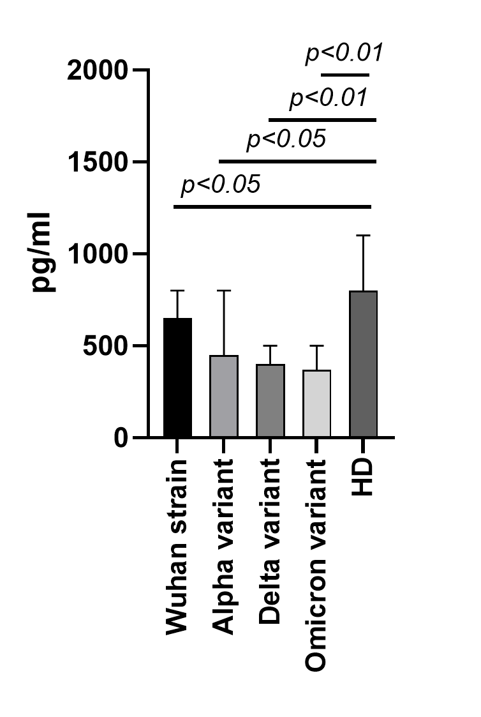

Figure 2. MDC/CCL22 concentrations in the blood plasma of COVID-19 convalescents (n=69) in comparison to infected patients in the acute phase (n=51) and healthy donors (n=56). Bars represent median concentrations (pg/ml). Whiskers represent the 75th quartile.



Figure 3. Role of MDC/CCL22 in immunity and the SARS-CoV-2 infectious process. I - MDC/CCL22 influence on T lymphocyte maturation in thymus via the CCR4 receptor. The presence of this chemokine also mediates an adequate balance between regulatory T cells and helper T cells, thus creating restrictions on inflammatory reactions. II - SARS-CoV-2 influence on T cell maturation in thymus via depletion of MDC/CCL22: A - decrease in MDC/CCL22 concentrations associated with selective binding to SARS-CoV-2 viral peptides; B - restriction of MDC/CCL22 secretion by producer cells due to their functional failure.

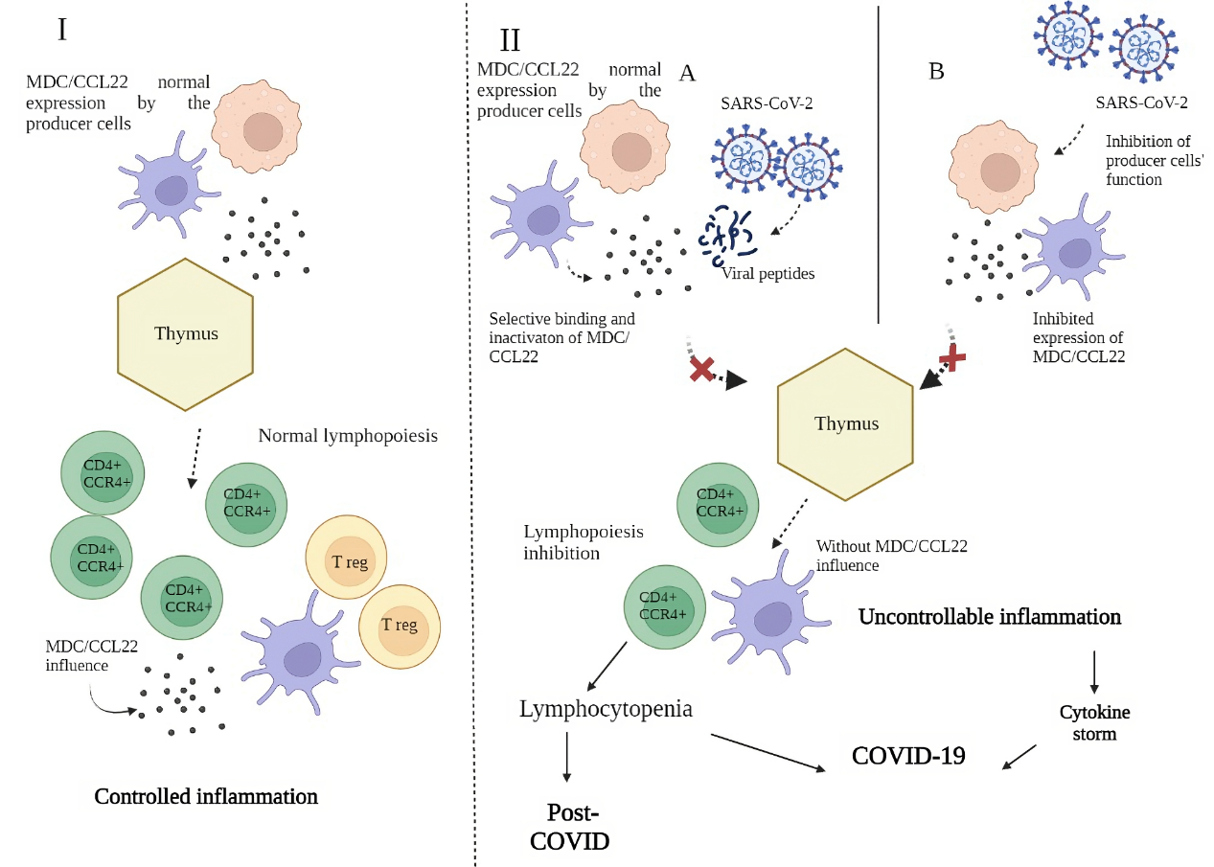

**ТИТУЛЬНЫЙ ЛИСТ_МЕТАДАННЫЕ**

**Блок 1. Информация об авторе ответственном за переписку**

**Коробова Зоя Романовна** - Младший научный сотрудник лаборатории молекулярной иммунологии, Санкт-Петербургский научно-исследовательский институт эпидемиологии и микробиологии им. Пастера;

старший лаборант кафедры иммунологии, Первый Санкт-Петербургский государственный медицинский университет им. И.П. Павлова

Почтовый адрес: ул. Мира, 14, Санкт-Петербург, Россия, 197101

Телефон: +79214002683

Email: [zoia-korobova@yandex.ru](mailto:zoia-korobova@yandex.ru)

Zoia R. Korobova - Senior Assistant, Department of Immunology, Pavlov First State Medical University of Saint Petersburg

Junior Research Associate, Laboratory of Molecular Immunology, Saint Petersburg Pasteur Institute

Ulitsa Mira, 14, Saint Petersburg, Russia, 197101

Phone: +79214002683

Email: [zoia-korobova@yandex.ru](mailto:zoia-korobova@yandex.ru)

**Блок 2. Информация об авторах**

Тотолян Арег Артемович - Директор, академик РАН, д.м.н., проф., Санкт-Петербургский научно-исследовательский институт эпидемиологии и микробиологии им. Пастера;

заведующий кафедрой иммунологии, Первый Санкт-Петербургский государственный медицинский университет им. И.П. Павлова

Areg A. Totolian - MD, PhD, professor, Academician of Russian Academy of Science, Head of Saint Petersburg Pasteur Institute, Chair of Department of Immunology, Pavlov First State Medical University of Saint Petersburg

**Блок 3. Метаданные статьи**

**MDC/CCL22 DEPLETION IN COVID-19 AND POST-COVID**

**СНИЖЕНИЕ MDC/CCL22 ПРИ COVID-19 И В ПОСТКОВИДНОМ СИНДРОМЕ**

**Сокращенное название статьи для верхнего колонтитула:**

MDC/CCL22 IN COVID-19

MDC/CCL22 ПРИ COVID-19

**Ключевые слова:** макрофагальный хемокин, COVID-19, хемокины, мультиплексный анализ, пост-ковидный синдром, дендритные клетки

**Ключевые слова:** macrophage derived chemokine, COVID-19, chemokines, multiplex analysis, post-COVID, dendritic cells

Материалы Форума "ДНИ ИММУНОЛОГИИ В САНКТ-ПЕТЕРБУРГЕ 2023"

Количество страниц текста – 4, количество таблиц – 0, количество рисунков – 3.

14.04.2023

**СПИСОК ЛИТЕРАТУРЫ**

|  |  |  |  |
| --- | --- | --- | --- |
| **Порядковый номер ссылки** | **Авторы, название публикации и источника, где она опубликована, выходные данные** | **ФИО, название публикации и источника на английском** | **Полный интернет-адрес (URL) цитируемой статьи или ее doi.** |
| 1 | Арсентьева Н.А., Любимова Н.Е., Бацунов О.К., Коробова З.Р., Станевич О.В., Лебедева А.А., Воробьев Е.А., Воробьева С.В., Куликов А.Н., Лиознов Д.А., Шарапова М.А., Певцов Д.Э., Тотолян А.А. Цитокины в плазме крови больных COVID-19 в острой фазе заболевания и фазе полного выздоровления*// Медицинская иммунология*. 2021.– 23(2). – С. 311-326. | **Arsentieva N.A., Liubimova N.E., Batsunov O.K., Korobova Z.R., Stanevich O.V., Lebedeva A.A., Vorobyov E.A., Vorobyova S.V., Kulikov A.N., Lioznov D.A., Sharapova M.A., Pevtcov D.E., Totolian A.A**. Plasma cytokines in patients with COVID-19 during acute phase of the disease and following complete recovery. *Medical Immunology (Russia). 2021, 23(2), 311-326. (In Russ.)* | doi: 10.15789/1563-0625-PCI-2312 |
| 2 | **Arsentieva N.A., Liubimova N.E., Batsunov O.K., et al.** Predictive value of specific cytokines for lethal COVID-19 outcome. *Russian Journal of Infection and Immunity.б 2022., Vol. 12., N. 5., pp. 859-868.* | - | doi: 10.15789/2220-7619-PVO-2043 |
| 3 | **Boechat JL, Chora I, Morais A, Delgado L.** The immune response to SARS-CoV-2 and COVID-19 immunopathology - Current perspectives. *Pulmonology. 2021 Sep-Oct, 27(5), pp. 423-437.* | - | doi:10.1016/j.pulmoe.2021.03.008. |
| 4 | **Borczuk, A.C., Yantiss, R.K.** The pathogenesis of coronavirus-19 disease. *J Biomed Sci, 2022, 29, p. 87* | - | https://doi.org/10.1186/s12929-022-00872-53 |
| 5 | **Chang T, Yang J, Deng H, Chen D, Yang X, Tang ZH.** Depletion and Dysfunction of Dendritic Cells: Understanding SARS-CoV-2 Infection. *Front Immunol, 2022, Feb 21, 13, p. 843342.* | - | doi: 10.3389/fimmu.2022.843342 |
| 6 | **Ghizlane EA, Manal M, Abderrahim EK, Abdelilah E, Mohammed M, Rajae A, Amine BM, Houssam B, Naima A, Brahim H.** Lymphopenia in Covid-19: A single center retrospective study of 589 cases. *Ann Med Surg (Lond), 2021, Sep, 69, p. 102816.* | - | doi: 10.1016/j.amsu.2021.102816. |
| 7 | **Korobova ZR, Arsentieva NA, Liubimova NE, Batsunov OK, Dedkov VG, Gladkikh AS, Sharova AA, Adish Z, Chernykh EI, Kaschenko VA, Ratnikov VA, Gorelov VP, Stanevich OV, Kulikov AN, Pevtsov DE, Totolian AA.** Cytokine Profiling in Different SARS-CoV-2 Genetic Variants. *Int J Mol Sci, 2022, Nov 16, 23(22), 14146.* | - | doi: 10.3390/ijms232214146. PMID: 36430621; PMCID: PMC9692520. |
| 8 | **Liu YC, Kuo RL, Shih SR.** COVID-19: The first documented coronavirus pandemic in history. *Biomed J. 2020 Aug, 43(4), pp. 328-333.* | - | doi: 10.1016/j.bj.2020.04.007. |
| 9 | **Merad M, Blish CA, Sallusto F, Iwasaki A.** The immunology and immunopathology of COVID-19. *Science, 2022, Mar 11, 375(6585), pp. 1122-1127.* | - | doi: 10.1126/science.abm8108 |
| 10 | **Salamanna F, Maglio M, Landini MP, Fini M.** Body Localization of ACE-2: On the Trail of the Keyhole of SARS-CoV-2. *Front Med (Lausanne), 2020, Dec 3, 7:594495.* | - | doi: 10.3389/fmed.2020.594495. |
| 11 | **Tufa A, Gebremariam TH, Manyazewal T, Getinet T, Webb DL, Hellström PM, Genet S.** Inflammatory mediators profile in patients hospitalized with COVID-19: A comparative study. *Front Immunol, 2022 Jul 25, 13:964179.* | - | doi: 10.3389/fimmu.2022.964179. |
| 12 | **Ubanako P, Xelwa N, Ntwasa M.** LPS induces inflammatory chemokines via TLR-4 signalling and enhances the Warburg Effect in THP-1 cells. *PLoS One, 2019,Sep 27, 14(9):e0222614.* | - | doi: 10.1371/journal.pone.0222614. |