**Экспрессия молекул CD56 и Tim-3 на разных субпопуляциях моноцитов периферической крови при беременности**

Орлова Е. Г.,

Логинова О. А.

«Институт экологии и генетики микроорганизмов УрО РАН» – филиал ПФИЦ УрО РАН

**CD56 and Tim-3 molecule expression in different monocyte subsets in physiological pregnancy**

Orlova E. G.,

Loginova O. A.

«Institute of Ecology and Genetics of Microorganisms, UB RAS» – branch of Perm Federal Research Center UB RAS

**Резюме**

Моноциты периферической крови играют важную роль в защите организма от патогенов и участвуют в поддержании физиологической беременности. Периферические моноциты мигрируют в децидуальную оболочку и образуют пул децидуальных макрофагов, которые участвуют в формировании и развитии тканей плаценты. Функции моноцитов периферической крови также существенно меняются, что связано с системным изменением иммунореактивности при беременности. Популяция моноцитов периферической крови фенотипически и функционально неоднородна. Выделяют несколько субпопуляций моноцитов в зависимости от экспрессии CD14 и CD16. Также в периферической крови присутствуют CD56-позитивные и Tim-3 (T–клеточного Ig и белка 3, содержащего домен муцина) - экспрессирующие моноциты. CD56 и Tim-3 играют важную роль в регуляции функциональной активности моноцитов. Однако изменение их экспрессии на разных субпопуляциях моноцитов периферической крови при беременности остается малоизученным. Поэтому целью исследования являлось изучение экспрессии CD56 и Tim-3 разными субпопуляциями моноцитов человека при беременности. Мононуклеарные клетки выделяли из периферической крови беременных женщин (срок беременности 29 недель (28-31) путем центрифугирования в градиенте плотности и анализировали методом проточной цитометрии. Группу сравнения составляли здоровые небеременные женщины (в фолликулярной фазе менструального цикла) фертильного возраста (21-29 лет). Установлено, что беременные женщины имели более низкий процент классических CD14hi/CD16-моноцитов в периферической крови по сравнению с небеременными. Процентное содержание промежуточных (CD14hi/CD16+) и неклассических (CD14low/CD16+) моноцитов не отличалось от небеременных. Экспрессия молекулы CD56 обнаруживалась всех субпопуляциях моноцитов как у беременных, так и у небеременных женщин. Беременные женщины имели более высокий процент CD56-позитивных классических (CD14hiCD16-) и неклассических (CD14lowCD16+) моноцитов, чем небеременные. Процент CD56-позитивных промежуточных моноцитов (CD14hiCD16+) не отличался от небеременных. У беременных женщин процентное содержание дубльпозитивных CD56+Tim-3+ классических (CD14hiCD16-) и неклассических (CD14lowCD16+) моноцитов было выше, чем у небеременных. Количество CD56+Tim-3+промежуточных моноцитов (CD14hiCD16+) не отличалось у беременных и небеременных. Таким образом, при физиологической беременности экспрессия молекул CD56 и Tim-3 меняется на разных субпопуляциях моноцитов периферической крови.

**Ключевые слова:** классические моноциты, неклассические моноциты, промежуточные моноциты, CD56, Tim-3, периферическая кровь, беременность.

**Abstract**

Monocytes play an important role in the systemic immune defense against pathogens and maintaining physiological pregnancy. During pregnancy peripheral monocytes migrate into the decidua and form the pool of decidual macrophages which participate in the formation and development of placental tissues. The population of peripheral blood monocytes is phenotypically and functionally heterogeneous. In humans, there are different monocyte subsets depending on the expression of CD14 and CD16. CD56-positive monocytes are found in healthy women. Their number is positively correlated with body mass index, body fat. Tim-3 (T–cell Ig and mucin domain-containing protein 3) expression is observed in peripheral monocytes during pregnancy. It is known that peripheral monocyte functions effectively change at pregnancy to form the immune tolerance at the maternal-fetal interface and the systemic immune defense against pathogens. However, the monocyte phenotype shift during pregnancy remain poorly understood. Therefore the aim of the study was to evaluate the CD56 and Tim-3 expressions in monocyte subsets in human pregnancy. Peripheral blood mononuclear cells were isolated from peripheral blood of pregnant women (gestational age 29 weeks (28-31) by density gradient centrifugation and analyzed by flow cytometry. Peripheral blood of healthy non-pregnant fertile women (in follicular phase of the menstrual cycle) aged 21 – 29 years was studied as control. Pregnant women had a lower percentage of classical CD14hi/CD16- monocytes in comparison with non-pregnant. The percentages of intermediate (CD14hi/CD16+) and non-classical (CD14low/CD16+) monocytes did not change. The CD56 molecule expression was observed in all monocyte subsets in pregnant and non-pregnant women. Pregnant women had a higher percentage of CD56-positive classical (CD14hiCD16-) and non-classical (CD14lowCD16+) monocytes than non-pregnant. The percentage of CD56-positive intermediate (CD14hiCD16+) monocytes did not changed. The percentages of double-positive CD56+Tim-3+ classical (CD14hiCD16-) and non-classical (CD14lowCD16+) monocytes were increased in pregnant women. The numbers of double-positive CD56+Tim-3+intermediate (CD14hiCD16+) monocytes did not changed. Thus, the CD56 and Tim-3 expressions in different monocyte subsets were changed in human pregnancy.

**Keywords:** classical monocytes, non-classical monocytes, intermediate monocytes, CD56, Tim-3, peripheral blood, pregnancy.

**Introduction**

Monocytes play an important role in the systemic immune defense against pathogens and maintaining physiological pregnancy [2]. Monocytes origin in the bone marrow and circulate in the peripheral blood. Monocytes phagocytose, produce cytokines and present antigens to naïve lymphocytes [2, 7]. During pregnancy peripheral monocytes migrate into the decidua and form the pool of decidual macrophages which since with natural killer cells participate in the formation and development of placental tissues [2, 6]. In humans, there are two main monocyte subpopulations depending on the expression of CD14 and CD16: classical (CD14hiCD16-), non-classical (CD14lowCD16+), and intermediate subpopulation (CD14hiCD16+) [7, 10]. CD14 is a pattern recognition receptor and was first identified as a marker of monocytes to initiate intracellular responses to bacterial antigens [2]. CD16 is the FcγRIII receptor responsible for antibody-dependent phagocytic activity [2]. Monocytes are able to differentiate into many cells types. Classical monocytes are the main sources of the macrophage pool in tissues [7, 10]. Only a minor proportion of classical monocytes differentiates into intermediate, and most of the intermediate monocytes finally mature into non-classical monocytes [7, 10]. Classical monocytes are considered mature; they show pronounced phagocytic activity and are capable of producing reactive oxygen species and cytokines through activation of toll like receptors signaling pathway [7, 10]. Non-classical monocytes do not produce reactive oxygen species but are better at production of pro-inflammatory cytokines [7, 10]. Non-classical monocytes patrol the surface of the endothelium and infiltrate tissues under normal state and during inflammation [7, 10]. Non-classical monocytes are involved in resolving inflammation and restoring the tissue and releasing cytokines [7, 10]. The intermediate monocyte role is poorly understood, but given the high expression level of MHC-II they probably participate in antigen presentation and activation of T lymphocytes [5, 7, 10]. It is known that peripheral monocyte functions effectively change at pregnancy to form the immune tolerance at the maternal-fetal interface and the systemic immune defense against pathogens [11]. However, the monocyte phenotype shift during pregnancy remain poorly understood.

CD56-positive monocytes are found in low frequencies in the peripheral blood of healthy individuals [3, 4]. Their number is expanded in obesity, autoimmune diseases and correlated positively with body mass index, body fat, C-reactive protein [3]. The CD56+ monocyte characteristics are controversial now. Some authors note effective production of reactive oxygen intermediates and pro-inflammatory cytokines by CD56+ monocytes, and are more efficient antigen-presenting function or dysregulated cytokine response to inflammatory stimuli [3, 4]. There are not CD56+ monocyte characteristics at physiological pregnancy.

Tim-3 (T–cell Ig and mucin domain-containing protein 3) molecule plays critical role in function regulation of innate and adaptive immune cells during pregnancy [11]. Tim-3 expressions are observed in peripheral monocytes during pregnancy [11]. However, the Tim-3 expression in different peripheral blood monocyte subsets during physiological pregnancy are not elucidated. The aim of the study was to evaluate the occurrence of CD56 and Tim-3 expression in monocyte subsets in human pregnancy.

Materials and Methods. Peripheral blood of healthy pregnant women in third trimester (gestational age 29 weeks (28-31) aged 21 – 29 years was studied (n=7). Peripheral blood of healthy non-pregnant fertile women (in follicular phase of the menstrual cycle) aged 21 – 29 years was studied as control (n=7). The inclusion criteria were the absence of acute and chronic somatic, endocrine, autoimmune, genetic diseases; compliance with diet, treatment with contraceptive and hormonal, anti-inflammatory or antibacterial drugs. This study was approved by the local ethics committee of the Institute of Ecology and Genetics of Microorganisms of the Ural Branch of the Russian Academy of Sciences in accordance with the Helsinki Declaration. Written informed consent was received from all participants.

Peripheral blood samples were collected in sodium heparin vacutainer tubes. Peripheral blood mononuclear cells (PBMC) were obtained from peripheral blood by ficoll-verografin (1.077g/cm3) density gradient centrifugation. PBMC was collected for further flow cytometry analysis.

Monocytes were harvested for flow cytometry using the following antibodies: CD14 (PE anti-human CD14, clone ME5E2, "BioLegend", UK), CD16 (FITC anti-human CD16, clone 3G8, "BioLegend", UK ), CD3 (APC/Cy7 anti-human CD3, clone UCHT1, "BioLegend", UK), CD56 (Brilliant Violet 605™  anti-human CD56 (NCAM), clone HCD56, "BioLegend", UK), CD366 (APC anti-human CD366 (Tim-3), clone F38-2E2, "BioLegend", UK), isotype controls (APC Mouse IgG1, κ Isotype Ctrl, "BioLegend", UK; Brilliant Violet 605™ Mouse IgG1, κ Isotype Ctrl "BioLegend", UK). Cells were labeled with Zombie (Zombie UV™ Fixable Viability Kit, BioLegend) to assess viability. Gating strategy was presented in Fig. 1. Flow cytometry was performed on a CytoFlex S flow cytometer using CytExpert and Kaluza 1.5 software (Beckman Coulter, USA).

The data were presented as median and the lower and upper quartiles, Me (LQ; UQ). Statistical analyses were performed using "GraphPad Prism version 8.01" (StatSoft, USA). The Kolmogorov-Smirnov test was used for verifying normal distribution. The significance of the difference between two groups was determined using the two-tailed unpaired *t*-test. The differences were considered as significant at *p<0.05*.

Result and discussion. To investigate the subsets of monocytes in peripheral blood of pregnant women PBMC were isolated from peripheral blood and analyzed by flow cytometry. Three subpopulations of monocytes in peripheral blood of pregnant and non-pregnant women: classical (CD14hiCD16-), non-classical (CD14lowCD16+), and intermediate subpopulation (CD14hiCD16+) were identified according to the literature [7, 10]. Classical monocytes were the predominant subpopulation in both pregnant and non-pregnant women (Fig.1, 2a). Pregnant women had a lower percentage of classical CD14hi/CD16- monocytes in comparison with non-pregnant (Fig. 2a). The percentages of intermediate (CD14hi/CD16+) and non-classical (CD14low/CD16+) monocytes did not change in pregnant women in comparison with non-pregnant (Fig. 2a). Obtained results are in accordance with the data of another authors [2]. It is known that a minor proportion of classical monocytes matures into intermediate monocytes and subsequently into non-classical monocytes [7]. The majority of classical monocytes transform in tissue macrophages [2]. Therefore the decrease in the number of classical monocytes can be explained by their migration into tissues at pregnancy and maturation in macrophages [2]. The data about monocyte subset changes in peripheral blood at pregnancy are controversial, which may reflect the influence of methods used for monocyte isolation, gating strategy, gestational ages [5].

The CD56 molecule expression was observed in all monocyte subsets in pregnant and non-pregnant women (Fig. 2d). Obtained results are in accordance with the data of other authors [3, 4]. Pregnant women had a higher percentage of CD56-positive classical (CD14hiCD16-) and non-classical (CD14low/-CD16+) monocytes than non-pregnant. The percentage of CD56-positive intermediate (CD14hiCD16+) monocytes did not changed compared non-pregnant women. It is established that monocytes have intensive adhesion to endothelium due to high expression of adhesion molecules (CD11a, CD11b, CD11c, CD29) during physiological pregnancy [6]. CD56 (neural cell adhesion molecule) plays an important role in the recruitment of monocytes into the tissues [3]. Therefore it may be supposed that CD56 high expression in monocytes explained the mechanism of transendothelial migration of monocytes during physiological pregnancy. Additionally there were strong associations between the number of CD56+ classical monocytes and fat mass increase in human [3], which is also associated with late pregnancy.

The coexpression of CD56 and Tim-3 molecules were determined in all monocyte subsets in pregnant and non-pregnant women (Fig. 2b). It was shown that the percentages of double-positive CD56+Tim-3+ classical (CD14hiCD16-) and non-classical (CD14lowCD16+) monocytes were increased at third trimester of pregnancy. The numbers of double-positive CD56+Tim-3+intermediate (CD14hiCD16+) monocytes did not changed. The percentages of Tim-3-positive classical (CD56-CD14hiCD16-) and non-classical (CD56-CD14lowCD16+) monocytes was decreased at third trimester of pregnancy (Fig. 2c). The numbers of Tim-3-positive intermediate (CD56-CD14hiCD16+) monocytes did not changed. According to the literature, Tim-3 signaling effectively stimulate the functional activity of innate immune cells to maintain the systemic immune defense against pathogens [1, 11]. Some authors had reported the participation of Tim-3 signaling in monocyte phagocytic activity stimulation [1]. There are no studies about Tim-3 expression on different monocyte subsets during physiological pregnancy. It may supposed that changes in CD56 and Tim-3 expression in different monocyte subsets occurred in third trimester of physiological pregnancy are important in their function regulation.

Thus, the CD56 and Tim-3 expressions in different monocyte subsets were changed in human pregnancy. The obtained results are important for understanding the underlying mechanism of immune dysfunctions during pregnancy and could have significant value in treating of reproductive disorders associated with monocyte dysfunctions.

**Acknowledgements**

This study was carried out within the framework of the state task, the state topic registration number: № AAAA-A19-119112290007-7.

**РИСУНКИ**

**Fig. 1.** Gating strategy monocytes subsets and assessment of Tim-3 and CD56 expression

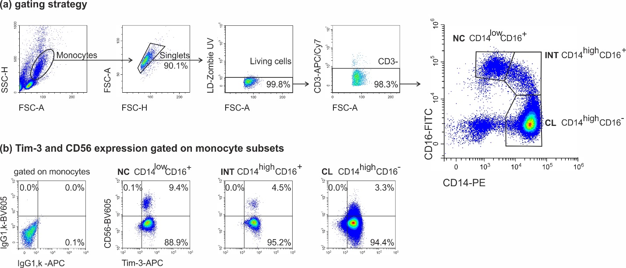

Note: (a) Monocytes gate selection according to the forward (FSC-A) and side (SSC-H) scattering parameters; discrimination of doublets according to the FSC-A/FSC-H parameters; discrimination between dead and live cells by LIVE/DEAD-ZOMBIE UV stained; selection of CD3- cells in the peripheral blood PBMC living cell gate; the number of the monocytes subsets was determined as a percentage of CD14lowCD16+ (non-classical, NC), CD14highCD16+ (intermediate, INT) and CD14highCD16- (classical, CL) in the gate of CD3-negative monocytes;

(b) Expression of Tim-3 and CD56 in monocytes subsets.

**Fig.** **2.** Assessment of the monocytes subsets and Tim-3 and CD56 expression.

(a) Assessment of the of monocytes subsets (NC, INT, CL) in non-pregnant (NP) and pregnant women, 3rd trimester (P, III);

(b) Percentage of co-expressions of Tim-3 and CD56 (Tim-3+СD56+) (c) (Tim-3+СD56-) and (d) (СD56-) in monocytes subsets in non-pregnant (NP) and pregnant women, 3rd trimester (P, III).

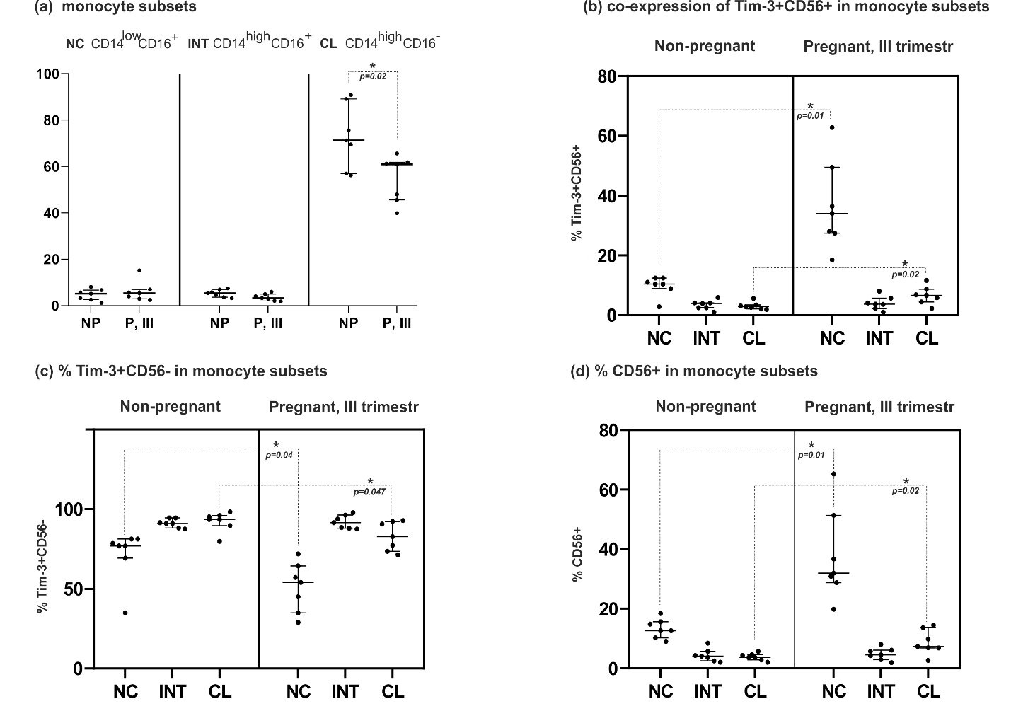

Note: In fig. 2 data are presented as median and the lower and upper quartiles, Me (LQ; UQ); \**p* valueby two-tailed unpaired *t*-test in corresponding subsets in NP and (P, III) groups.

**ТИТУЛЬНЫЙ ЛИСТ_МЕТАДАННЫЕ**

**Блок 1. Информация об авторе ответственном за переписку**

**Орлова Екатерина Григорьевна**

Доктор биологических наук, в.н.с. лаборатории иммунорегуляции

«Институт экологии и генетики микроорганизмов УрО РАН» – филиал ПФИЦ УрО РАН

Российская Федерация, г. Пермь, ул. Голева, 13

[orlova_katy@mail.ru](mailto:orlova_katy@mail.ru)

**Orlova Ekaterina Grigorievna**

Doctor of Biological Sciences, Leading Researcher of the Laboratory of Immunoregulation,

“Institute of Ecology and Genetics of Microorganisms, UB RAS” – branch of Perm Federal Research Center UB RAS; Russian Federation,

614081, Perm, Goleva, 13

ORCID: 0000-0003-1195-8962

[orlova_katy@mail.ru](mailto:orlova_katy@mail.ru)

**Блок 2. Информация об авторах**

**Логинова Ольга Александровна**

кандидат биологических наук, м.н.с. лаборатории иммунорегуляции

«Институт экологии и генетики микроорганизмов УрО РАН» – филиал ПФИЦ УрО РАН

Российская Федерация, 614081, г. Пермь, ул. Голева, 13

[jallopukki@ya.ru](mailto:jallopukki@ya.ru)

*Loginova Olga Alexandrovna*

Ph.D. (Biology), Junior Researcher of the Laboratory of Immunoregulation

“Institute of Ecology and Genetics of Microorganisms, UB RAS” – branch of Perm Federal Research Center UB RAS, Perm, Russian Federation;

614081, Perm, Goleva, 13

ORCID: 0000-0001-6050-8656

[jallopukki@ya.ru](mailto:jallopukki@ya.ru)

**Блок 3. Метаданные статьи**

Экспрессия молекул CD56 и Tim-3 на разных субпопуляциях моноцитов периферической крови при беременности

CD56 and Tim-3 molecule expression in different monocyte subsets in physiological pregnancy

**Сокращенное название статьи для верхнего колонтитула:**

CD56 и Tim3 на моноцитах при беременности

CD56 and Tim3 in monocytes at pregnancy

**Ключевые слова:** классические моноциты, неклассические моноциты, промежуточные моноциты, CD56, Tim-3, периферическая кровь, беременность.

**Keywords:** classical monocytes, non-classical monocytes, intermediate monocytes, CD56, Tim-3, peripheral blood, pregnancy.

Материалы Форума "ДНИ ИММУНОЛОГИИ В САНКТ-ПЕТЕРБУРГЕ 2023"

Количество страниц текста – 4

Количество таблиц – 0

Количество рисунков – 2

Дата поступления: 14.04.2023

**СПИСОК ЛИТЕРАТУРЫ**

|  |  |  |
| --- | --- | --- |
| **Порядковый номер ссылки** | **ФИО, название публикации и источника на английском** | **Полный интернет-адрес (URL) цитируемой статьи или ее doi.** |
| 1 | Chabtini L., Mfarrej B., Mounayar M., Zhu B., Batal I., Dakle P. J., Smith B. D., Boenisch O., Najafian N., Akiba H., Yagita H., Guleria I. TIM-3 regulates innate immune cells to induce fetomaternal tolerance. Journal of immunology, 2013, Vol. 190, no. 1, pp. 88–96. | https://doi.org/10.4049/jimmunol.1202176 |
| 2 | Faas M. M., and P de Vos. Maternal monocytes in pregnancy and preeclampsia in humans and in rats. Journal of reproductive immunology, 2017, Vol. 119, pp. 91-97. | doi:10.1016/j.jri.2016.06.009 |
| 3 | Friedrich K., Sommer M., Strobel S., Thrum S., Blüher M., Wagner U., Rossol M. Perturbation of the Monocyte Compartment in Human Obesity. Front Immunol, 2019, Vol. 10, pp. 1874. | doi: 10.3389/fimmu.2019.01874. PMID: 31440251 |
| 4 | Krasselt M., Baerwald C., Wagner U. Rossol M. CD56+ monocytes have a dysregulated cytokine response to lipopolysaccharide and accumulate in rheumatoid arthritis and immunosenescence. Arthritis research & therapy, 2013, Vol. 15, no. 5, pp. R139. | <https://doi.org/10.1186/ar4321> |
| 5 | Meggyes M., Nagy D.U., Feik T., Boros A., Polgar B., Szereday L. Examination of the TIGIT-CD226-CD112-CD155 Immune Checkpoint Network during a Healthy Pregnancy. Int J Mol Sci., 2022, Vol. 23, no. 18, pp. 10776. | doi:10.3390/ijms231810776 |
| 6 | Mikhaylova V.A., Klimovskaya Y.S., Amanova N.V., Zaynulina M.S., Selkov S.A., Sokolov D.I. Expression of adhesion molecules on blood monocytes during pregnancy. Medical Immunology, 2010, Vol. 12, no. 4-5, pp. 337-342. | <https://doi.org/10.15789/1563-0625-2010-4-5-337-342> |
| 7 | Patel A.A., Zhang Y., Fullerton J.N., Boelen L., Rongvaux A., Maini A. A., Bigley V., Flavell R. A., Gilroy D. W., Asquith B., Macallan D., Yona S.  The fate and lifespan of human monocyte subsets in steady state and systemic inflammation. J Exp Med., 2017, Vol. 214, no.7, pp. 1913-1923. | doi:10.1084/jem.20170355 |
| 8 | Sokolov D.I., Seljutin A.V., Lesnichija M.V., Arzhanova O.N. Selkov S.A. Subpopulation profile of peripheral blood lymphocytes in normal and preeclampsia pregnancy, 2007, Vol. LVI, no. 4, pp. 17-23. | <https://cyberleninka.ru/article/n/subpopulyatsionnyy-sostav-limfotsitov-perifericheskoy-krovi-beremennyh-zhenschin-s-gestozom/viewer> |
| 9 | Vishnyakova P., Kuznetsova M., Poltavets A., Fomina M., Kiseleva V., Muminova K., Potapova A., Khodzhaeva Z., Pyregov A., Trofimov D., Elchaninov A., Sukhikh G., Fatkhudinov T. Distinct gene expression patterns for CD14++ and CD16++ monocytes in preeclampsia. Sci Rep., 2022, Vol. 12, no. 1, pp. 15469. | doi: 10.1038/s41598-022-19847-5. |
| 10 | Ziegler-Heitbrock L., Ancuta P., Crowe S., Dalod M., Grau V., Hart D. N., Leenen P. J., Liu Y. J., MacPherson G., Randolph G. J., Scherberich J., Schmitz J., Shortman K., Sozzani S., Strobl H., Zembala M., Austyn J. M., Lutz, M. B. Nomenclature of monocytes and dendritic cells in blood. Blood, 2010, Vol. 116, no. 16, pp. e74–e80. | https://doi.org/10.1182/blood-2010-02-258558 |
| 11 | Zhao J., Lei Z., Liu Y., Li B., Zhang L., Fang H., Song C., Wang X., Zhang G. M., Feng Z. H., Huang B. Human pregnancy up-regulates Tim-3 in innate immune cells for systemic immunity. Journal of immunology, 2009, Vol. 182, no. 10, pp. 6618–6624. | https://doi.org/10.4049/jimmunol.0803876 |