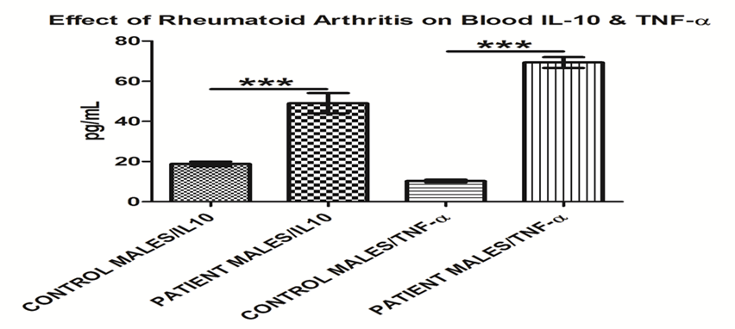
Figure 1:effect of rheumatoid on blood IL-10&TNF-α
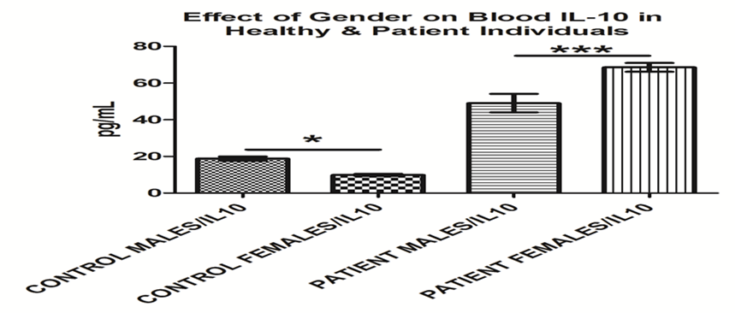
Figure 2: effect of gender on blood IL-10 in healthy & patient individuals
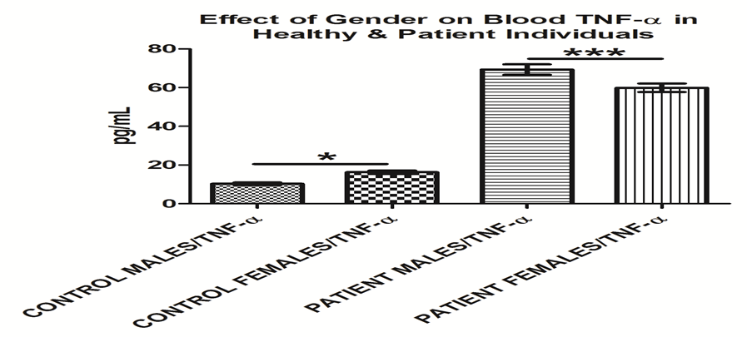
Figure 3: effect of gender on blood TNF-α in healthy & patient individuals

Table 1: HLA-DR genotyping in RA patients in comparison to healthy control.
HLA-DR allele | RA | % | Control | % | OR | IOR | EF | PF | P value
*0203 | 1 | 3.33% | 0 | 0.00% | 2.085 | 0.480 | 0.52 | -1.08 | NS
*0204 | 0 | 0.00% | 1 | 5.00% | 0.213 | 4.692 | 0.00 | 0.00 | NS
*0302 | 0 | 0.00% | 1 | 5.00% | 0.213 | 4.692 | 0.00 | 0.00 | NS
*0308 | 4 | 13.33% | 5 | 25.00% | 0.479 | 2.090 | -4.36 | 0.81 | NS
*0309 | 1 | 3.33% | 0 | 0.00% | 2.085 | 0.480 | 0.52 | -1.08 | NS
*0318 | 1 | 3.33% | 0 | 0.00% | 2.085 | 0.480 | 0.52 | -1.08 | NS
*0319 | 2 | 6.67% | 0 | 0.00% | 3.596 | 0.278 | 1.44 | 3.25 | NS
*0329 | 1 | 3.33% | 0 | 0.00% | 2.085 | 0.480 | 0.52 | -1.08 | NS
*0402 | 0 | 0.00% | 1 | 5.00% | 0.213 | 4.692 | 0.00 | 0.00 | NS
*0405 | 1 | 3.33% | 0 | 0.00% | 2.085 | 0.480 | 0.52 | 1.08 | NS
*0415 | 0 | 0.00% | 1 | 5.00% | 0.213 | 4.692 | 0.00 | 0.00% | NS
*0435 | 1 | 3.33% | 1 | 5.00% | 0.661 | 1.513 | -0.51 | 0.34 | NS
*0440 | 1 | 3.33% | 0 | 0.00% | 2.085 | 0.480 | 0.52 | -1.08 | NS
*0442 | 1 | 3.33% | 0 | 0.00% | 2.085 | 0.480 | 0.52 | -1.08 | NS
*0446 | 1 | 3.33% | 0 | 0.00% | 2.085 | 0.480 | 0.52 | -1.08 | NS
*0456 | 2 | 6.67% | 2 | 10.00% | 0.649 | 1.541 | -1.08 | 0.52 | NS
*0459 | 1 | 3.33% | 4 | 20.00% | 0.186 | 5.364 | -4.36 | 0.81 | NS
*0603 | 0 | 0.00% | 1 | 5.00% | 0.213 | 4.692 | 0.00 | 0.00 | NS
*0701 | 9 | 30.00% | 0 | 0.00% | 18.116 | 0.055 | 8.50 | 1.13 | .007
*0707 | 1 | 3.33% | 0 | 0.00% | 2.085 | 0.480 | 0.52 | -1.08 | NS
*0713 | 1 | 3.33% | 0 | 0.00% | 2.085 | 0.480 | 0.52 | -1.08 | NS
*0716 | 0 | 0.00% | 1 | 5.00% | 0.213 | 4.692 | 0.00 | 0.00 | NS
*0717 | 4 | 13.33% | 3 | 15.00% | 0.849 | 1.178 | -0.71 | 0.42 | NS
*1001 | 1 | 3.33% | 0 | 0.00% | 2.085 | 0.480 | 0.52 | -1.08 | NS
*1101 | 1 | 3.33% | 1 | 5.00% | 0.661 | 1.513 | -0.51 | 0.34 | NS
*1107 | 3 | 10.00% | 0 | 0.00% | 5.218 | 0.192 | 2.43 | 1.70 | NS
*1109 | 2 | 6.67% | 2 | 10.00% | 0.649 | 1.541 | -1.08 | 0.52 | NS
*1112 | 1 | 3.33% | 0 | 0.00% | 2.085 | 0.480 | 0.52 | 1.08 | NS
*1122 | 2 | 6.67% | 0 | 0.00% | 3.596 | 0.278 | 1.44 | 3.25 | NS
*1137 | 2 | 6.67% | 0 | 0.00% | 3.596 | 0.278 | 1.44 | 3.25 | NS
*1152 | 1 | 3.33% | 0 | 0.00% | 2.085 | 0.480 | 0.52 | -1.08 | NS
*1156 | 0 | 0.00% | 1 | 5.00% | 0.213 | 4.692 | 0.00 | 0.00 | NS
*1165 | 1 | 3.33% | 1 | 5.00% | 0.661 | 1.513 | -0.51 | 0.34 | NS
*1301 | 0 | 0.00% | 1 | 5.00% | 0.213 | 4.692 | 0.00 | 0.00 | NS
*1302 | 2 | 6.67% | 0 | 0.00% | 3.596 | 0.278 | 1.44 | 3.25 | NS
*1359 | 1 | 3.33% | 0 | 0.00% | 2.085 | 0.480 | 0.52 | -1.08 | NS
*1360 | 1 | 3.33% | 0 | 0.00% | 2.085 | 0.480 | 0.52 - | 1.08 | NS
*1370 | 0 | 0.00% | 1 | 5.00% | 0.213 | 4.692 | 0.00 | 0.00 | NS
*1374 | 0 | 0.00% | 3 | 15.00% | 0.082 | 12.200 | 0.00 | 0.00 | NS
*1401 | 2 | 6.67% | 0 | 0.00% | 3.596 | 0.278 | 1.44 | 3.25 | NS
*1525 | 1 | 3.33% | 0 | 0.00% | 2.085 | 0.480 | 0.52 | -1.08 | NS
*1601 | 1 | 0.00% | 1 | 5.00% | 0.213 | 4.692 | 0.00 | 0.00 | NS
*1605 | 0 | 3.33% | 0 | 0.00% | 2.085 | 0.480 | 0.52 | -1.08 | NS
*1607 | 1 | 3.33% | 0 | 0.00% | 2.085 | 0.480 | 0.52 | -1.08 | NS
*1613 | 0 | 0.00% | 1 | 5.00% | 0.213 | 4.692 | 0.00 | 0.00 | NS
*6389 | 1 | 3.33% | 0 | 0.00% | 2.085 | 0.480 | 0.52 | -1.08 | NS
*9045 | 1 | 3.33% | 0 | 0.00% | 2.085 | 0.480 | 0.52 | -1.08 | NS
*0403 | 2 | 6.67% | 7 | 35.00% | 0.158 | 6.333 | -10.67 | 0.91 | 0.020

